The Marriage Reset Workbook
Final polished workbook edition with updated final page, corrected lesson order, branding improvements, and refined course flow.

Final Step & Ongoing Rhythm
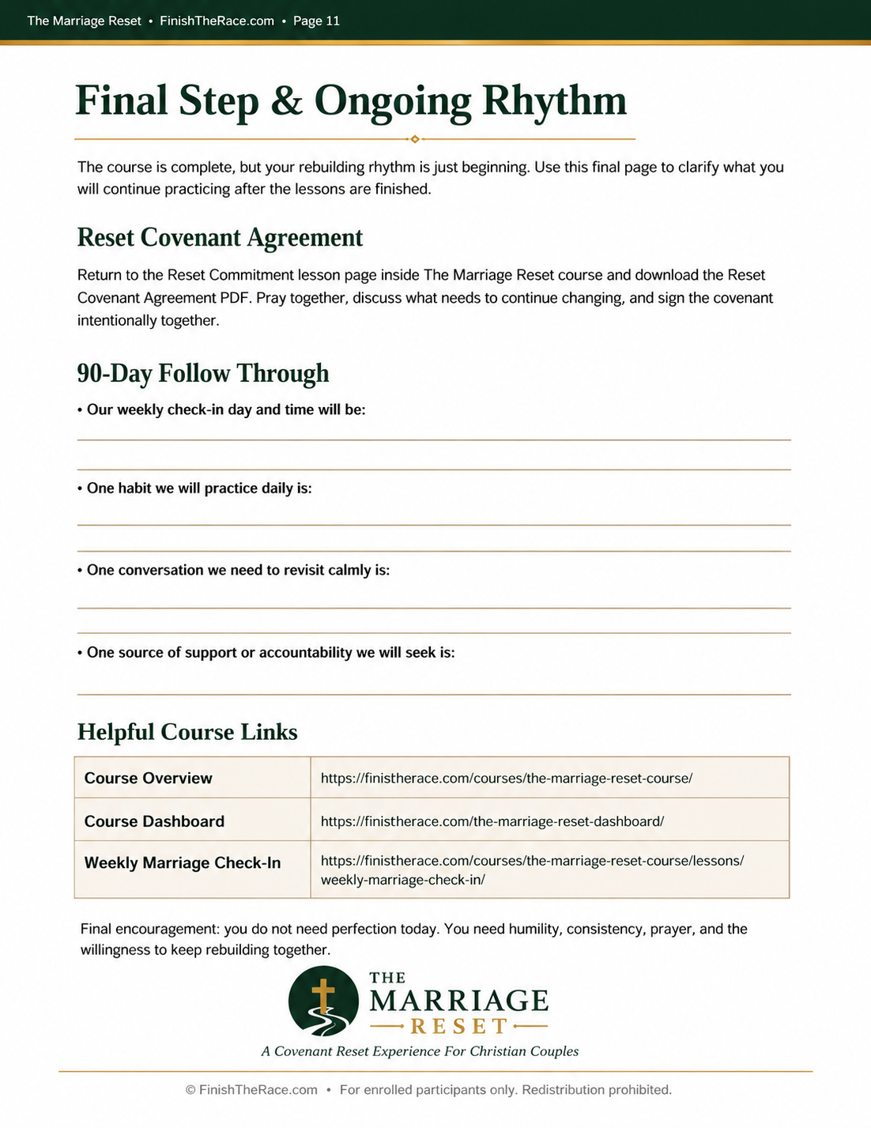
© FinishTheRace.com — For enrolled participants only. Duplication, redistribution, resale, uploading, or public sharing is prohibited.

